CHEESECAKE CUP CHEESECAKE CUP

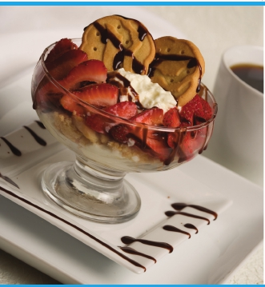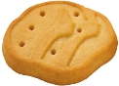

**Ingredients:** **Yields 8 servings**

· 1 BOX OF TREFOILS GIRL SCOUT COOKIES

· INSTANT CHEESECAKE PUDDING MIX (CHECK THE BOX FOR

EXTRA INGREDIENTS)

· 12 OZ. CREAM CHEESE (SOFTENED)

· STRAWBERRIES

· CHOCOLATE SYRUP

**Directions:**

CRUSH HALF BOX OF TREFOILS. MIX SOFTENED CREAM CHEESE

AND CHEESECAKE PUDDING UNTIL SMOOTH. LAYER CRUSHED

COOKIES AND CHEESECAKE PUDDING IN A CUP AND REPEAT

LAYERING OF INGREDIENTS. GARNISH WITH STRAWBERRIES (OR

YOUR FAVORITE BERRIES) AND 2 FULL TREFOIL COOKIES. DRIZZLE

WITH CHOCOLATE SYRUP.